
Template for the headteacher’s report to the governing board

Executive summary from the headteacher
Describe in brief the successes and challenges of the term
NSET Days (1st–2nd September 2026)
The autumn term began with a two-day INSET focused on setting clear expectations for the year ahead. Day 1 covered behaviour and expectations, an introduction to the trust-wide SEEAT 6 (Principle 1: "Ready to Learn"), presentation expectations, and time for staff to prepare classrooms and environments ready for the children's return. Day 2 focused on safeguarding, Read Write Inc training for EYFS and KS1, adaptive teaching in KS2, lunchtime expectations with midday staff, a SEND update, and curriculum updates from every subject lead. This gave staff a shared, consistent starting point for the term and underpinned much of what has followed since.
Westborough Walking
"Westborough Walking" was introduced as a calm, consistent way for children to move around the school. This has contributed directly to a calmer overall school environment, which has been noted by midday supervisors, office staff, teachers, and site staff.
Decluttering & Calm Environments
Classroom decluttering has been introduced across the school, alongside consistent hessian boards, to support calm, low-stimulus learning environments. The intended impact is a more focused, settled atmosphere for pupils; this is already being seen in how much calmer the school feels day-to-day.
Behaviour & Rewards
There is now much greater consistency in the application of the behaviour policy across all staff. The consistent use of Dojos has led to more positive recognition being given to pupils, and Golden Time has been introduced alongside a range of other incentives. This consistency has contributed to a noticeable improvement in behaviour, with some children previously identified as needing targeted support now meeting the school's high expectations.
Uniform
Uniform standards have improved significantly since September.
Attendance
The school achieved 97% attendance in the first full week back, which was celebrated with a whole-school rewards event (a DJ session at Friday lunchtime).
Trust Standards Meeting
A Standards Meeting was held with Toni Kittle, Chief Education Officer for SEEAT, to review the previous year's outcomes and agree the focus areas needed to ensure progress and raise attainment moving forward.
Challenges and Next Steps
While embedding change takes time, we are seeing clear progress. A small number of children continue to need sustained, individualised support around their behaviour, which has led to the creation of consistent behaviour management plans for these pupils. This progress will now be monitored through regular behaviour walks. Adaptive teaching to meet the needs of all pupils.

Key DfE Changes
Benedict's Law (Allergy Safety in Schools)
From September 2026, new statutory guidance known as Benedict's Law requires all covered schools in England to have, publish, and keep under review a dedicated allergy safety policy. Schools are required to have a whole-school allergy policy, provide staff training to recognise and respond to anaphylaxis, have access to emergency adrenaline auto-injectors, develop individual healthcare or allergy plans for pupils with diagnosed allergies, and improve communication and record-keeping around allergies and reactions. We are reviewing our current policy and practice against this guidance to ensure full compliance.
Free School Meals (FSM) Eligibility Expansion
From the start of the 2026/27 academic year, all children from households in receipt of Universal Credit will be entitled to a free school meal, regardless of household earnings - removing the previous £7,400 earnings threshold. Going forward there will be two categories: Targeted FSM (households earning £7,400 or less) and a new Expanded FSM category for households above this threshold who still receive Universal Credit. Transitional protections, in place since April 2018, ended on 31 August 2026, meaning pupils must now meet the new eligibility criteria to continue receiving free meals. We are working to ensure eligible families are aware of this change and supported to apply, given the wider implications for both pupil wellbeing and Pupil Premium funding.

School improvement priorities
Update on school improvement priorities
- Primary focus on GLD, Phonics, YR4 MTC and SATS (all key metrics and all key group)
- The School Development Plan links in with how we are going to score in line with national for KS2 combined (reading, writing and maths) as we were 5% below national and improve our GLD. All other outcomes were inline or better than national.
Quality of Education
1.1 To embed consistently effective teaching through adaptive practice and the SEEAT Six.
Achievement
2.1 To improve mathematics and overall achievement, particularly for disadvantaged pupils.
2.2. To raise attainment so that it falls in-line or above National for combined in reading, writing and maths.
Behaviour and Attitudes
3.1 To secure positive behaviour, attendance and belonging through measurable impact.
Personal Development
4.1 To strengthen inclusion through evidence-based evaluation.
Leadership and Management
5.1 To develop leadership at all levels, particularly subject leadership, through robust monitoring, evaluation and accountability.

ADMISSIONS
Number of pupils currently on roll (including by year) | Mon 21 Sep 2026, 13:45
  Year | Reg | Males | Females | Total
  N2 | Bluebell | 7 | 13 | 20
   | Total | 7 | 13 | 20
  Year 0 | Daisy - 0L | 13 | 16 | 29
   | Sunflower - 0S | 10 | 18 | 28
   | Total | 23 | 34 | 57
  Year 1 | 1HS | 17 | 13 | 30
   | 1R | 13 | 15 | 28
   | Total | 30 | 28 | 58
  Year 2 | 2S | 15 | 15 | 30
   | 2DF | 13 | 16 | 29
   | Total | 28 | 31 | 59
  Year 3 | 3K | 17 | 11 | 28
   | 3G | 20 | 8 | 28
   | Total | 37 | 19 | 56
  Year 4 | 4W | 12 | 18 | 30
   | 4C | 12 | 17 | 29
   | Total | 24 | 35 | 59
  Year 5 | 5P | 15 | 15 | 30
   | 5H | 15 | 16 | 31
   | Total | 30 | 31 | 61
  Year 6 | 6SM | 13 | 18 | 31
   | 6C | 16 | 13 | 29
   | Total | 29 | 31 | 60
   | Totals | 208 | 222 | 43
Number who have joined the school | 8 children  (6 moved into area, 2 from Milton Hall - moved as we are closer)
Number who have left | 4 children  (3 moved out of area, 1 started here and then got place at Milton Hall the next day)
Explanation of any changes since last term’s report

ATTENDANCE
Actual attendance against target / national target (including by year and by groups)
   | 2024-2025
  Whole school % attendance target | 97%
  Whole Academy % attendance | 96.8%
  Whole Academy % absence | 3.2%
  Whole Academy % pupils below 90% (PA) | 7.4%
  Whole Academy number of pupils below 90% (PA) | 32
  Boys | 93.7%
  Girls | 96.7%
  FSM | 96.3%
  CLA | 95.4%
  SEND (all) | 96.6%
  EHCP | 90.6%
Number of authorised and unauthorised absences | 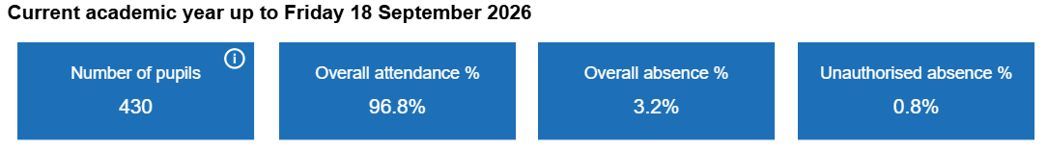
Explanation of any changes since last term’s report

SAFEGUARDING
Number of safeguarding incidents | 21 Safeguarding incidents.  ( There have been 133 since the beginning of term- the rest are behaviour).
Number of pupils with a child protection plan in place | Currently 0 CP cases.
% of Safeguarding training | All staff trained at the beginning of term. SEEAT have sent out a quiz and declaration.  One member of staff on long term sick and will need the training when she returns in October.
Some families have come back having issues during the Summer and as we are often the adults they trust we are meeting and discussing issues and things them may need in place . Sharon Pankhurst is checking in with families to see if they need food vouchers, we have contacted families who have had absences in the first 2 weeks so we can check for any vulnerabilities and have organised meetings to check in with families.
We have had 2 Encompass reports during the Summer and have spoken to the parents involved on our return and checked in with children. One child has started counselling as a result.
We have had a parent with significant mental health issues during the holiday, Prevention – Families First are now involved and that child has also started counselling as a result.
One of our SEN families have had a new baby and have needed extra support. CWD team are now involved.
Behaviour has been reported on significantly, we have changed the policy slightly and everyone is hyper vigilant about this. Children are also learning how this lands. This has been positive although we have a lot of entries.

Pupils with Special educational needs (SEN) and looked-after children (LAC)
Number of pupils on the SEN register | 117 on SEND Register (82 SS and 35 EHCP)
Number of LAC | 4
Most recent attainment data of SEND pupils Vs non-SEND pupils. | 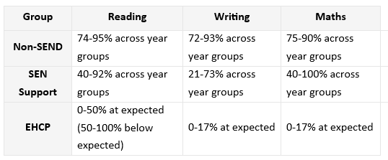
How is SEND provision being monitored? | SEND provision is monitored through regular pupil progress reviews, assessment data, classroom observations, provision mapping, and feedback from pupils, parents, and staff. Leaders analyse outcomes, evaluate interventions, and ensure support meets identified needs. Governors and senior leaders review compliance, resource allocation, and impact, enabling continuous improvement and accountability across the setting overall effectively.
Evaluation of strengths of provision and areas to develop (SEND) | Strong SEND provision includes early identification, personalised small-step targets, targeted interventions, effective phonics support, curriculum adaptations, rigorous progress tracking, and close collaboration with parents and external agencies. Positive progress is evident from starting points. Development priorities include improving SEND reading, writing fluency, sentence structure, and outcomes for pupils with complex needs.
Most recent attainment data of LAC pupils vs non-LAC pupils | 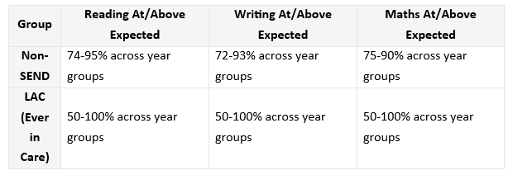
Evaluation of strengths of provision and areas to develop (LAC) | Strengths include identification of LAC pupils within SEND systems, targeted support, personalised provision, progress monitoring, and access to wider SEND interventions and external agency involvement. Areas for development include strengthening attainment tracking, analysing progress against non-LAC peers, and ensuring sharper evaluation of the impact of LAC-specific support strategies.

DISADVANTAGE
Number of children currently entitled to receive the pupil premium | 151
Current pupil premium allocation | 2025 - 2026  £204,525  2026 - 2027  To be reviewed at October Census to approx. (£1550 x 151) £234,050
Link to Pupil Premium review and current plan | The Westborough School - Pupil Premium

Behavioural reports
Number of suspensions | 0
Number of permanent exclusions | 0

For the table below: provide some context for the school’s performance and standards. This could include steps being taken to address any issues.

School performance and standards
Criteria | Term 1 | Term 2 | Term 3
EY GLD assessment | Baselines have now been completed
Y1 Phonics assessment | Baselines currently being completed
Y4 MTC assessment | Baselines Currently being completed
KS2 Reading assessment | KS2 have just completed their KS2 mock SATs – we are now looking at the data, completing QLAs and then delivering targeted interventions.
KS2 Maths assessment | As above
KS2 GPS assessment | As above
KS2 Writing assessment | As above

I have attached the previous academic years data as this was not available at the time of the last LGB meeting.

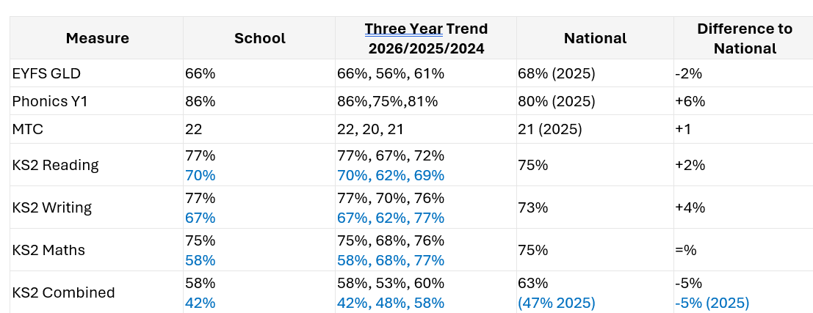

School Context
Measure | 2026 | National comparison
Number on roll | 443 | Well above average
% FSM6 (eligible for free school meals, last 6 years) | 34.2% | Close to average
% SEN Support | 22.4% | Well above average
% EHC Plan | 6.8% | Above average
% EAL (English as an Additional Language) | 43.6% | Above average
% Pupil stability | 81.5% | Close to average
School pupil-base deprivation | — | Above average
The school serves a diverse community: the largest ethnic group is White British (45.6%, below the national average of 59.8%), with significant representation from Asian or Asian British (Bangladeshi, Indian, Pakistani and other Asian backgrounds), Black African, and Mixed heritage groups.
ISDR Summary — Attendance & Behaviour
Daily attendance in 2025/26 is close to the national average. Termly attendance has shown a positive trend, moving from below average in 2018/19 and 2022/23 to close to average in the most recent two years (2023/24 and 2024/25). Persistent absence, while significantly above the national average in the three years to 2023/24, has improved to close to average (non-significant) in 2024/25 — a positive direction of travel. Suspension rates (both one or more, and two or more suspensions) have remained close to the national average across all recent years.
ISDR Summary — Achievement (Key Stage 2 & Phonics)
Performance against national averages over the three years to 2025 is broadly close to average across most headline measures, including RWM expected standard, reading, writing, EGPS, Year 4 Multiplication Tables Check, and phonics. Against similar schools, the picture is notably stronger — writing greater depth and RWM higher standard are both significantly above the similar-schools average over the three-year period, and several other measures (reading higher standard, writing expected standard, EGPS expected standard) are above the similar-schools average. Maths remains an area for continued focus: maths higher standard was significantly below the national average in 2025, and maths measures are generally below the similar-schools average — this aligns directly with the school improvement priority to improve mathematics and overall achievement, particularly for disadvantaged pupils.

school Policies for approval
NAME OF POLICY | SUMMARY OF CHANGES
Behaviour Policy | Refers to ‘1,2,3 Stop!’ low level beahviours are addressed with the children throughout the lesson which resets every lesson  Children know what the expectations are around what they could receive a 1, 2 and a 3 for  Children may be given instant 3 for behaviours that are more extreme.  Golden Time earned on a Friday for an additional break  Behaviours are explicitly taught  New incentives  Values changed to Ready, Respectful and Safe.
Safeguarding and Child  Protection Policy 2026 | Updated in-line with KCSIE  DDSL updated to David Tipper
SEEAT Restrictive Interventions and Use of Reasonable Force Policy 2026 | New statutory duty — every use of force, restraint or seclusion must now be recorded (same day, on CPOMS) and reported to parents in writing (same day, minimum required detail). Only exception: risk of serious harm to the child.  "Seclusion" is now formally defined — confining a pupil and preventing them leaving. Last resort only, shortest time, continuous supervision, subject to the same recording/reporting duty as physical restraint.  Explicit prohibited practices — clear list of things never permitted (e.g. anything affecting breathing, pressure to neck/chest, mechanical restraints, withholding food/toilet access).  No blanket "no-contact" rule — everyday contact (comforting a child, holding a young child's hand, a high-five) is explicitly permitted and not classed as a restrictive intervention.
SEEAT Suspensions and Permanent Exclusions Policy 2026 | Aligned to the July 2026 DfE guidance ("Suspension and permanent exclusion... including pupil movement"), effective from 26th July 2026 — the policy's legal basis and referenced timescales (15/50 school days for LGB review, 5th/6th day education duties) are unchanged from before, but now explicitly reference the updated guidance.  Managed moves and off-rolling are explicitly addressed — the policy is clear that using suspension/exclusion, or informal pressure (e.g. asking parents not to bring a child in), to avoid a pupil's name being on roll is unlawful off-rolling.  LGB's duty to consider reinstatement is clearly timetabled (15 or 50 school days depending on suspension length) — a concrete standing responsibility for governors to be aware of.  Independent Review Panel rights for parents remain in place for permanent exclusions, including the right to request a SEND expert be present.

Staffing information (to include changes over the term)
Leavers  Tonya  Jesse  Kay | Starters  David  Toby and Vida (2 new trainees teachers with The Learning in Harmony Trust)
Changes to the staffing structure –
No changes, as of yet.
There are currently 3 job adverts out.
Teacher: replacement for Jesse (Y1 part time teacher on Wednesday and Thursday)
LSA: to replace John who is retiring after the October half term 2026
Midday: as someone left.

Evaluation of school’s professional learning programme
Type of PROFESSIONAL LEARNING PROGRAMME | Expenditure | Impact

Parent/carer engagement
Include information on events, questionnaires and any successes and challenges from the term

Since September, I have prioritised being visible and approachable to families, regularly being present on the school gates to get to know parents and carers and to be available for anyone who wishes to chat. I have also met with the PTA, who are kindly organising a bake sale on 25th September to raise funds for the school. Meet the Teacher sessions will be held later this term, at which I will also be present, giving me the opportunity to meet parents I don't otherwise see at the gate.

