The Westborough School Coronavirus Essential Visitor Protocol: Contractors and Non-School based Professionals

Essential Visitors   | - The school will only allow essential visitors on site for:  - School regular maintenance and emergencies  - For teaching and learning reasons  - Routine medical tests e.g. School nurse  - SEND observations and assessments  - Training that must be undertaken in person  - Safeguarding reasons  - Health and safety reasons  - All visits will be at the school’s discretion. | Arranging the Visit   | - Visitors must make an appointment to visit school. An exception may be made if it is for essential work for a Child Protection or Child in Need case.  - Visitors without an appointment may be asked to leave and make an appointment for a later date.  - The visitor and school will agree a time and date for the visit.  - Where possible this will be undertaken when there are no pupils in school and avoiding dropping off and picking up times.  - The visitor will receive a copy of this protocol before final agreement of time/date has been made so we are able to check visitors understand and agree to its detail.  - The school will ensure this protocol is sent with a read receipt via email.
Covid-19 Symptoms  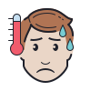 | - If you have any one of the following symptoms you must not visit school:  - a high temperature – this means you feel hot to touch on your chest or back (you do not need to measure your temperature)  - a new, continuous cough – this means coughing a lot for more than an hour, or 3 or more coughing episodes in 24 hours (if you usually have a cough, it may be worse than usual)  - a loss or change to your sense of smell or taste – this means you've noticed you cannot smell or taste anything, or things smell or taste different to normal  - If you have any of these symptoms you must go home and arrange for a test. | Arrival  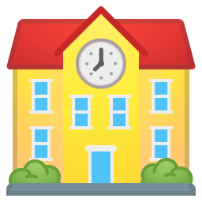 | - Visitors must arrive at agreed time (please contact the office if you are unable to do this)  - Report directly to the school reception office unless other prior arrangements have been made.  - Record your arrival on the school’s visitor management system.  - In the event that the visit involves close contact* with anyone else on site, and that person develops symptoms and tests positive then contact details will need to be provided to the Public Health England for their Test and Trace system.
Health Conditions   | - Visitors who are clinically extremely vulnerable must take precautions by washing their hands regularly, avoiding touching their face and keeping 2 metres away from persons in school.  - We would expect that the employer has undertaken an individual risk assessment in these circumstances. | Hand Hygiene   | - Use hand sanitiser provided on entry to school.  - Wash hands after visiting the toilet and at regular intervals.  - Use hand sanitiser when leaving the building
Social Distancing  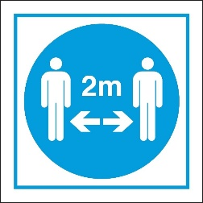 | - Visitors should observe social distancing whilst on the school premises wherever possible. That is:  - Meet as few persons as possible in school.  - Meet outside if possible.  - Maintaining a 2 metre social distance throughout the visit wherever possible. (This won’t be possible for certain support professionals)  - Any face to face meetings should be as short as possible (i.e. no longer than 15 minutes). | 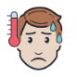  Becoming Symptomatic in school   | - Any visitor on site who exhibits symptoms of Covid 19 will be isolated and be asked to leave site.  - If you start to feel unwell whilst you are at school please let a member of staff know.  - If you develop symptoms up to 14 days after being in our school please call school to inform us so we are able to act in line with risk assessments and track and trace.  - You are encouraged to be tested if you have symptoms.
Site Visit   | - Items should not be shared during the visit if possible. If not possible, good hand hygiene should be observed.  - Minimise any touching of school fixtures, fittings and other contents.  - Visit as few rooms as possible. If unaccompanied you may be asked to report which rooms, you have visited so that touch points may be cleaned afterwards.  - PPE equipment will be available in all rooms along with cleaning materials. Visitors are free to bring their own PPE with them if they wish.  - If working with pupils, visit the minimum number of group “bubbles” necessary.  - Follow any one-way pedestrian systems that are in place.  - Observe any rooms restricted to visitors – e.g. staff room. Visitors may be allocated certain toilets.  - Windows and doors should be kept open during the visit but this may not always be possible / practicable.  - Face masks may be worn by visitors who are not working with pupils, but they are not a substitute for maintaining the required social distance. | Leaving School Site   | - Go straight to the office once you have finished your visit where you will be signed out.  - Remember to wash/sanitise your hands on leaving the school.
Fire Evacuation  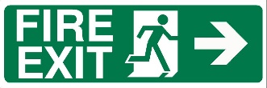 | - In the event of the fire alarm activation, the evacuation will be undertaken as normal, with the exception that there will be social distancing at the assembly point.

* Close contact within a school environment definition:
- Direct close contacts - face to face contact with a case for any length of time, within 1 metre, including being coughed on, a face to face conversation, or unprotected physical contact (skin to skin).
- Proximity contacts - extended close contact (within 1-2 metres for more than 15 minutes) with an infected individual.

